Name : Kirtesh Satish Admute
Roll No. : 258039
PRN : 250841220082
Module : DBT

CREATE TABLE Vehicle (
vid int primary key auto_increment,
vname varchar(20),
price double(9,2),
descr varchar(100)
);

CREATE TABLE customer (
custid int primary key auto_increment,
cname varchar(20),
address varchar(50)
);

CREATE TABLE salesman (
sid int primary key auto_increment,
sname varchar(20),
address varchar(100)
);

CREATE TABLE cust_vehicle(
custid int,
vid int,
sid int,
buy_price double(9,2),
constraint fk_custid foreign key(custid) references customer(custid),
constraint fk_vid foreign key(vid) references Vehicle(vid),
constraint fk_sid foreign key(sid) references salesman(sid)
);

insert into Vehicle(vname, price, descr)
values('Activa', 80000, 'ksldjfjksj'),
values('Santro', 800000, 'kdjfkjsd'),
values('Motor bike', 100000, 'fdkdfj');

INSERT INTO customer (Custid, Cname, address) VALUES
(1, 'Nilima', 'Pimpari'),
(2, 'Ganesh', 'Pune'),
(3, 'Pankaj', 'Mumbai');

INSERT INTO salesman(sname, address) VALUES
('Rajesh', 'Mumbai'),
('Seema', 'Pune'),
('Rakhi', 'Pune');

INSERT INTO cust_vehicle(custid, vid, sid, buy_price) VALUES
(1, 1, 10, 75000),
(1, 2, 10, 790000),
(2, 3, 11, 80000),
(3, 3, 11, 75000),
(3, 2, 10, 800000);

-- 1. create all given tables
-- Done ✔
-- 2. create index on vehicle table based on price
CREATE INDEX idx_price ON vehicle(price);
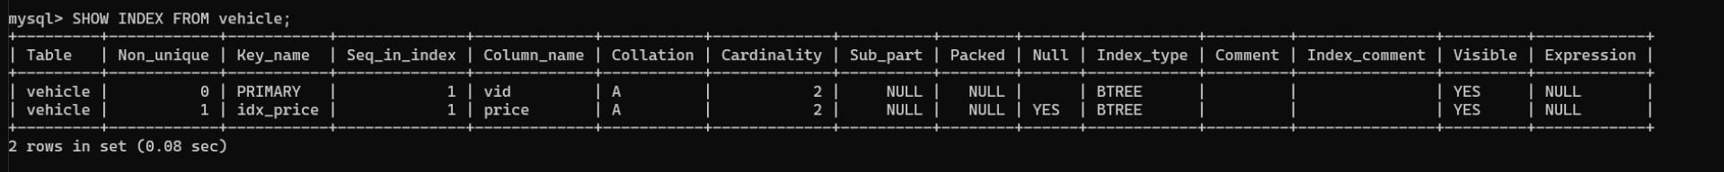
-- 3. find all customer name,vehicle name, salesman name, discount earn by all customer
-- discount = price - buy price
-- per = (discount /price )*100

select c.cname , v.vname, s.sname , round((( v.price -cs.buy_price)/v.price)*100, 2) as discount from customer c, Vehicle v , salesman s,cust_vehicle cs
where cs.vid = v.vid and cs.sid = s.sid and cs.custid =c.custid;
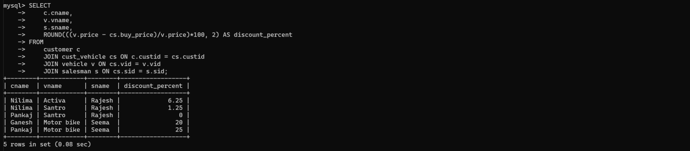

-- 4. find all customer name,vehicle name,salesman name for all salesman who stays in pune

select c.cname , v.vname, s.sname from customer c, Vehicle v , salesman s,cust_vehicle cs
where cs.vid = v.vid and cs.sid = s.sid and cs.sid in (select sid from salesman where address = 'Pune') and cs.custid =c.custid ;
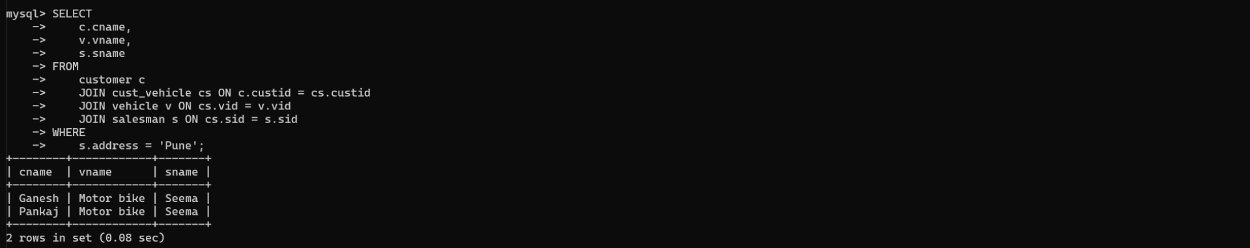

-- 5. find how many customers bought motor bike
select count(*) from cust_vehicle cv, vehicle v
where cv.vid = v.vid and cv.vid in (select vid from vehicle where vname = 'Motor bike');
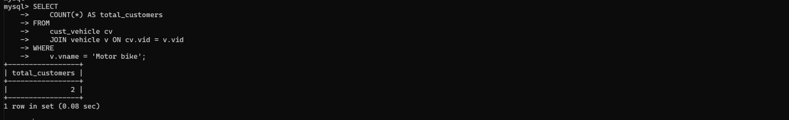

-- 6. create a view find_discount which displays output
-- -------to create view
-- create view find_discount
-- as
-- select cname,vname,price,buying_price,price-buying_price “discount”
-- from customer c inner join cust_vehicle cv on c.custid=cv.cid inner join vehicle v on
-- v.vid=cv.vid
-- --------to display discount
-- select * from find_discount;
create view find_discount as
select c.cname , v.vname, s.sname , round((( v.price -cs.buy_price)/v.price)*100, 2) as discount from customer c, Vehicle v , salesman s,cust_vehicle cs
where cs.vid = v.vid and cs.sid = s.sid and cs.custid =c.custid;

-- 7. find all customer name, vehicle name, salesman name, discount earn by all customer
-- alreadY done ✔😊
CREATE OR REPLACE VIEW find_discount AS
SELECT
c.cname,
v.vname,
s.sname,
v.price,
cs.buy_price,
ROUND((v.price - cs.buy_price), 2) AS discount_amount,
ROUND(((v.price - cs.buy_price)/v.price)*100, 2) AS discount_percent
FROM
customer c
JOIN cust_vehicle cs ON c.custid = cs.custid
JOIN vehicle v ON cs.vid = v.vid
JOIN salesman s ON cs.sid = s.sid;
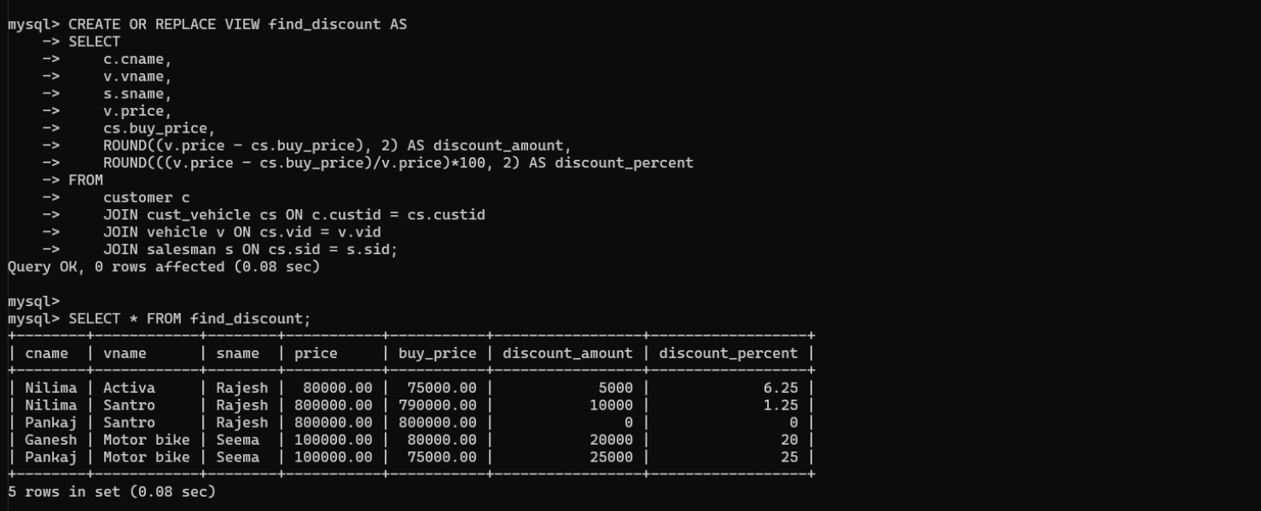

-- 8. create view my_hr to display empno,ename,job,comm for all employees who earn commission
create view my_hr1 as
SELECT empno , ename , job , comm from emp where comm is not null;
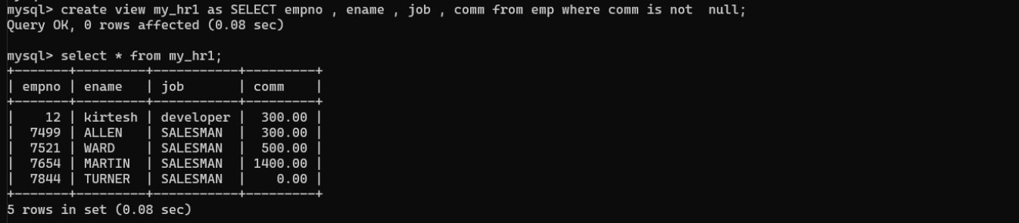
-- 9. create view mgr30 to display all employees from department 30
create view mgr30 as
select * from emp where deptno=30;
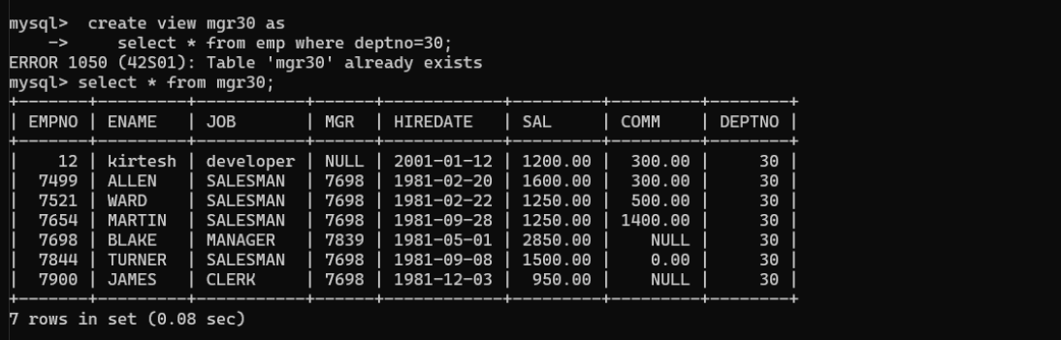

-- 10. insert 3 employees in view mgr30 check whether insertion is possible
-- yes its possible
INSERT INTO mgr30 (empno, ename, job, mgr, hiredate, sal, comm, deptno)
VALUES
(101, 'Kirtesh1', 'Developer', 100, '2025-10-16', 1200, NULL, 30),
(102, 'Kirtesh2', 'Tester', 100, '2025-10-16', 1000, 100, 30),
(103, 'Kirtesh3', 'Analyst', 100, '2025-10-16', 1500, 200, 30);

-- Check
SELECT * FROM mgr30;
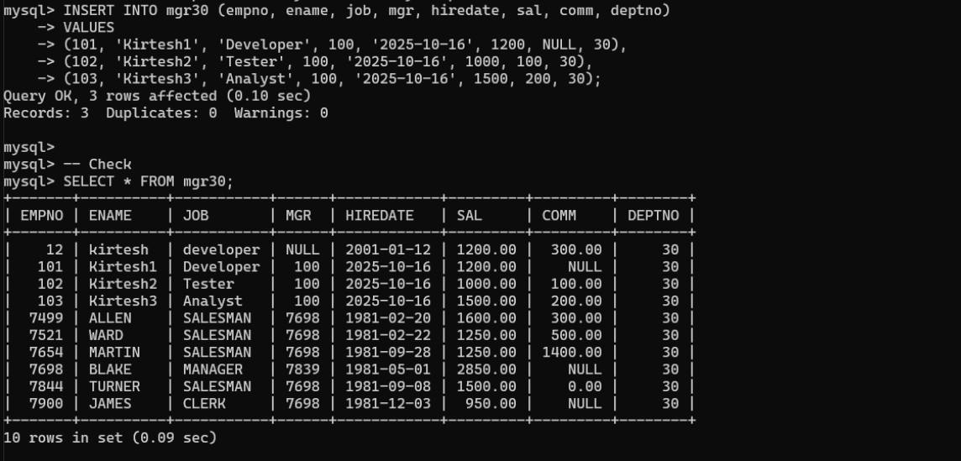
11. insert 3 records in dept and display all records from dept

-- Create dept table if not exists
CREATE TABLE IF NOT EXISTS dept (
deptno INT PRIMARY KEY,
dname VARCHAR(50),
loc VARCHAR(50)
);

INSERT INTO dept (deptno, dname, loc) VALUES
(10, 'Sales', 'Pune'),
(20, 'Finance', 'Mumbai'),
(30, 'IT', 'Delhi');

-- Display all records
SELECT * FROM dept;
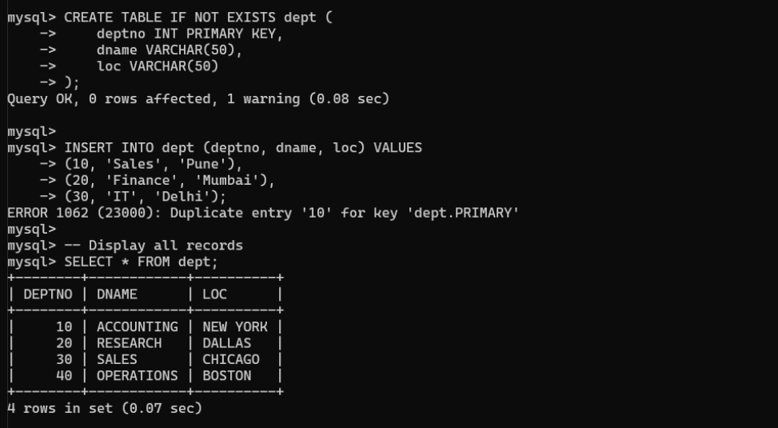

12. use rollback command check what happens
-- Start a transaction
START TRANSACTION;

INSERT INTO emp (empno, ename, job, mgr, hiredate, sal, comm, deptno)
VALUES
(201, 'A', 'Dev', 100, '2025-10-16', 1200, 100, 30);

SELECT * FROM emp WHERE empno = 201;

-- Rollback
ROLLBACK;

-- Check emp table, record 201 should NOT exist
SELECT * FROM emp WHERE empno = 201;
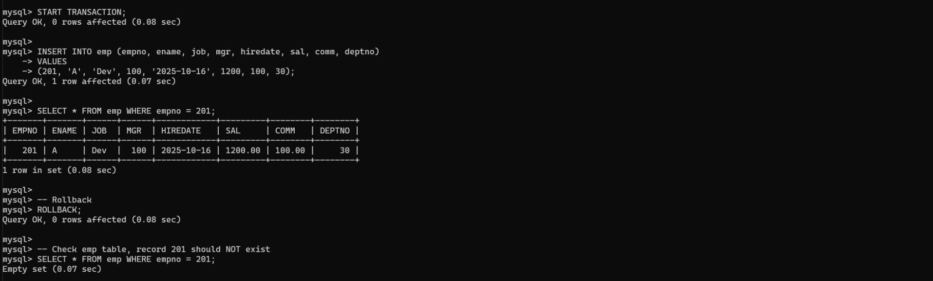

13. do the following
insert row in emp with empno 100
insert row in emp with empno 101
insert row in emp with empno 102
add savepoint A
insert row in emp with empno 103
insert row in emp with empno 104
insert row in emp with empno 105
add savepoint B
delete emp with empno 100
delete emp with emp no 104
rollback upto svaepoint B
check what all records will appear in employee table
rollback upto A
check what all records will appear in employee table
commit all changes
check what all records will appear in employee table
check whether you can roll back the contents.
START TRANSACTION;

-- Insert employees
INSERT INTO emp (empno, ename, job, mgr, hiredate, sal, comm, deptno)
VALUES (100,'Emp100','Dev',NULL,'2025-10-16',1200,NULL,30),
(101,'Emp101','Dev',NULL,'2025-10-16',1300,NULL,30),
(102,'Emp102','Dev',NULL,'2025-10-16',1400,NULL,30);
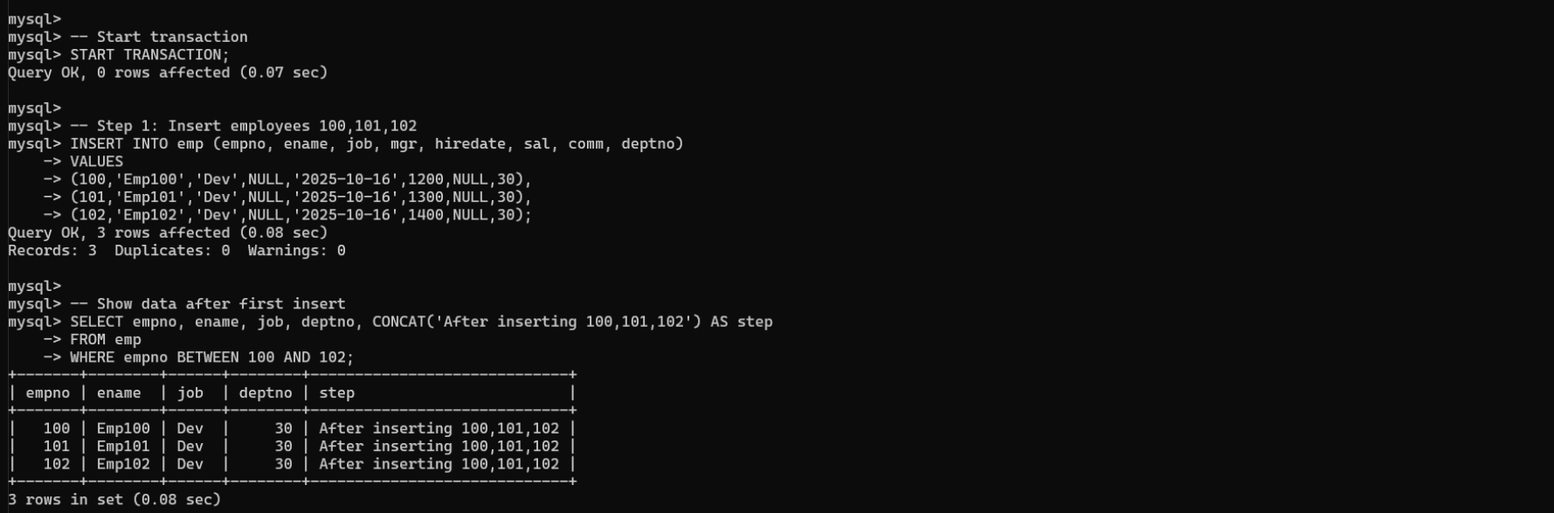

-- Savepoint A
SAVEPOINT A;

INSERT INTO emp (empno, ename, job, mgr, hiredate, sal, comm, deptno)
VALUES (103,'Emp103','Dev',NULL,'2025-10-16',1500,NULL,30),
(104,'Emp104','Dev',NULL,'2025-10-16',1600,NULL,30),
(105,'Emp105','Dev',NULL,'2025-10-16',1700,NULL,30);

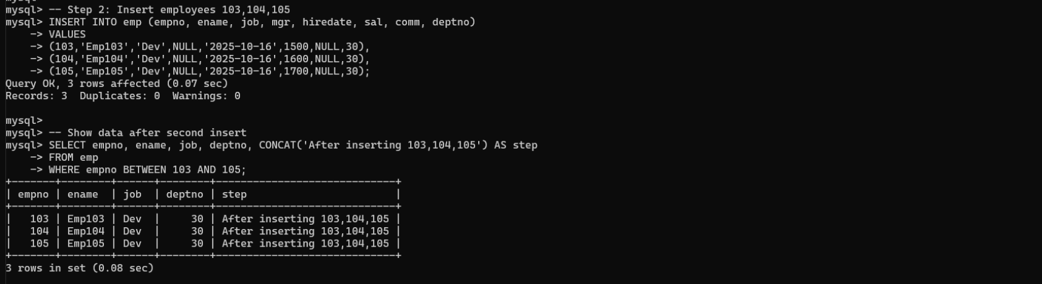
-- Savepoint B
SAVEPOINT B;

-- Delete some rows
DELETE FROM emp WHERE empno = 100;
DELETE FROM emp WHERE empno = 104;

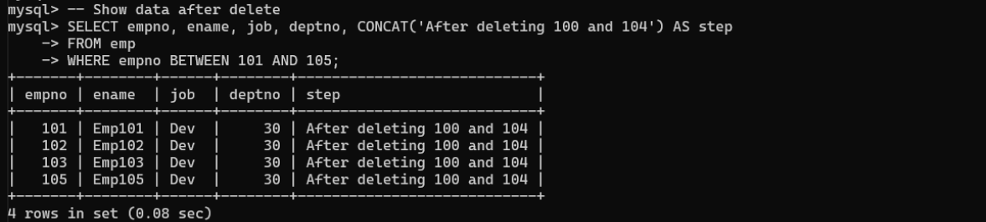
-- Rollback to B
ROLLBACK TO SAVEPOINT B;

-- Check what remains
SELECT * FROM emp;
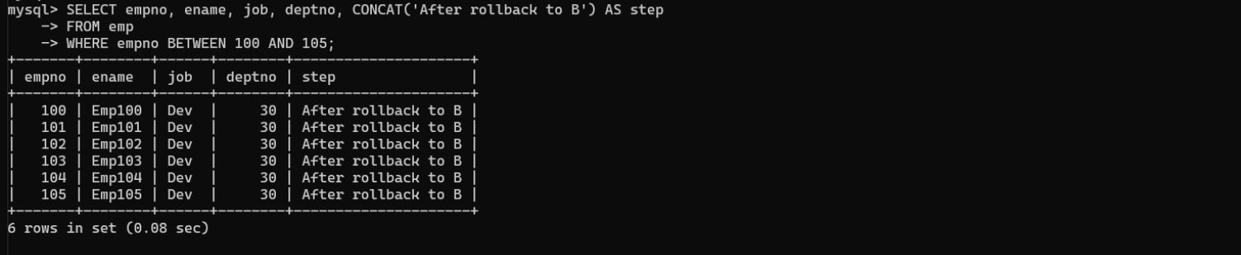

-- Rollback to A
ROLLBACK TO SAVEPOINT A;

-- Check what remains
SELECT * FROM emp;
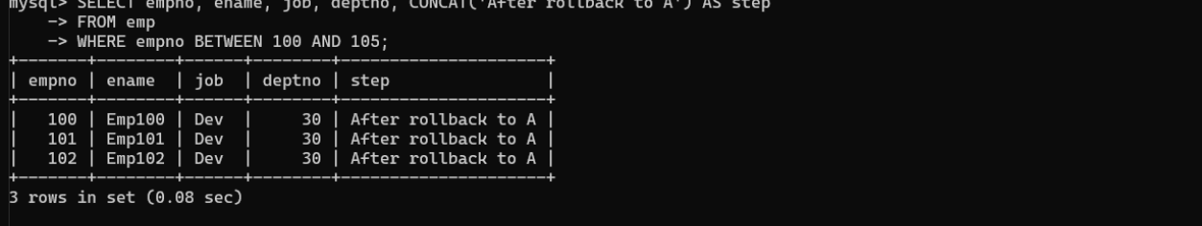
-- Commit all changes
COMMIT;

-- Final check
SELECT * FROM emp;
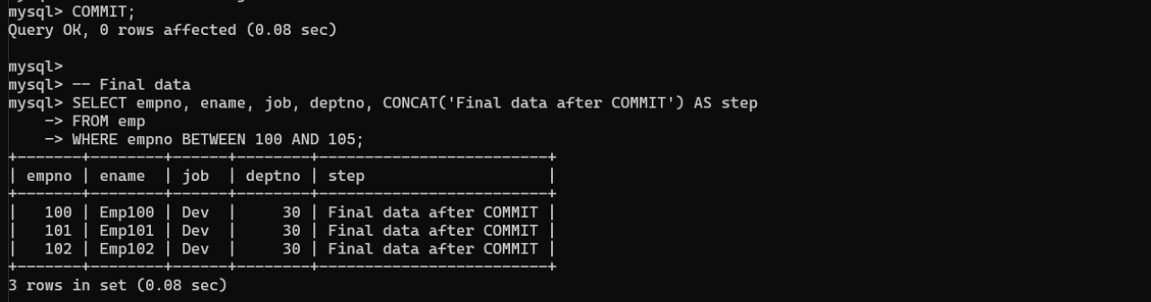

14. create a procedure getMin(deptno,minsal) to find minimum salary of given table.
DELIMITER $$

CREATE PROCEDURE getMin(IN dept INT, OUT minsal DOUBLE)
BEGIN
SELECT MIN(sal) INTO minsal
FROM emp
WHERE deptno = dept;
END $$

DELIMITER ;

-- Example usage
CALL getMin(30, @min_salary);
SELECT @min_salary;

